Tutorial Quiz for PHYS 101 : Week of September 17, 2007

Problems to be done during the first hour (choose any two)

Problem 15.9

A research submarine has 20-cm diameter window 8.0 cm thick. The manufacturer says that the window can withstand forces up to 1.0 ×10⁶ N. What is the submarine’s safe depth? The pressure inside the submarine is maintained at 1.0 atm.

Problem 15.10

A 20-cm-diameter circular cover is placed over a 10-cm-diameter hole that leads into an evacuated chamber. The pressure in the chamber is 20 kPa. How much force is required to pull the cover off?

Problem 15.17

Styrofoam has a density of 300 kg/m³. What is the maximum mass that can hang without sinking from a 50-cm-diamter Styrofoam sphere in water? Assume the volume of the mass is negligible compared to that of the sphere.

Problems for the second hour (choose 2)

Each problem is worth 10 points
A student may discuss the problems with other students but may not copy from others.

Problem 15.36

Suppose the density of the earth’s atmosphere were a constant 1.3 kg/m³, independent of height, until reaching the top. How thick would the atmosphere be?

Problem 15.37

Your science teacher has assigned you the task of building a water barometer. You’ve learned that the pressure of the atmosphere can vary by as much as 5% from 1 standard atmosphere as the weather changes.
- What minimum height must your barometer have?
- One stormy day the TV weather person says, “ The barometric pressure this afternoon is low 29.25 inches”. What is the height of the water in your barometer?

Problem 15.38

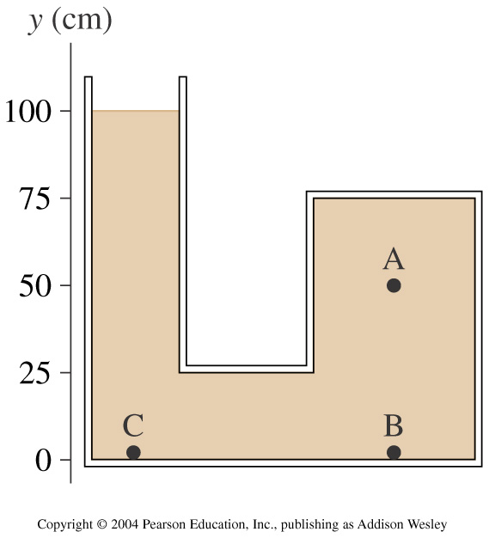

The container shown in the Figure 15.38 is filled with oil. It is open to the atmosphere on the left.

- What is the pressure at point A?
- What is the pressure difference between points A and B? Between points A and C?

